**Department of Computer Science and Engineering**

|  |  |
| --- | --- |
| **Course Code:CSE260** | **Credits: 1.5** |
| **Course Name: Digital Logic Design** | **Semester: Fall’18** |

**Lab 08  
How to Use Mux for Data Transmission**

1. **Topic Overview:**

The students will familiarize themselves with the mux. They will understand how to use mux to transfer data. They will also learn how to make 2:1 mux from 4:1 mux.

1. **Lesson Fit:**

The lab will follow the theory class.

1. **Learning Outcome:**

After this lecture, the students will be able to:

* 1. Use mux
  2. How to add multiple optional number in a same circuit with mux

1. **Anticipated Challenges and Possible Solutions**
   1. **Problem:** Student may not the understand function of the mux.

**Solution:** Explain the purpose of the mux.

* 1. **Problem:** Student may not understand how to use the selector to transfer data.

**Solution:** Explain the concept of the selector

* 1. **Problem:** Students may fail to map the mux into ic

**Solution:** Explain the mapping between the mux and the ic.

1. **Acceptance and Evaluation**

Students will show their progress as they complete each problem. They will be marked according to their class performance. Their maybe students who might not be able to finish all tasks, they will submit them later and give a viva to get their performance mark.

1. **Activity Detail**
   1. **Hour: 1  
      Discussion:**Explain the mux, selector, and adder. **Problem Task:** Set up mux with selector.
   2. **Hour: 2 & 3**

**Problem Task:** Set up adder ic and connect the output of the mux to adder and show the final output.

1. **Home tasks**
   1. Prepare a report based on the experiment.

**Lab 08 Activity List**

***Design and Implementation of the following circuit:***

Four 2 bit numbers A, B, C, D and two selection variables S1 and S2 are available. S1 will select either A or B and S2 will select either C or D. Depending on the two selection variables, the circuit will work in the following way.

|  |  |  |
| --- | --- | --- |
| **S1** | **S2** | **Operation** |
| 0 | 0 | A+C |
| 0 | 1 | A+D |
| 1 | 0 | B+C |
| 1 | 1 | B+D |

C3 S2 S1

X2 X1 Y2 Y1

S1

0 1

0 1

0 1

0 1

2:1

2:1

2:1

2:1

A2 A1 B2 B1 C2  C1 D2 D1

S1

S2

S2

2 bit Parallel Adder

**IC: MUX (74153) Adder: 7483**

**Report:**

The report should cover the followings

1. Name of the experiment
2. Objective
3. Required Components and Equipments
4. Experimental Setup (i.e., diagram of the circuit)
5. Results and Discussions
   1. Draw a circuit diagram which will compare three 4 bit numbers. You have Magnitude Comparators and 2:1 MUXs.

**Mux 74153**

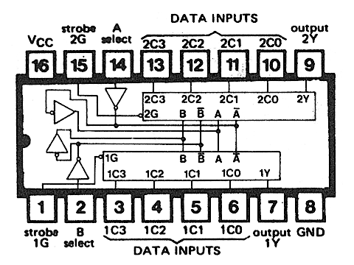

**Adder 7483**

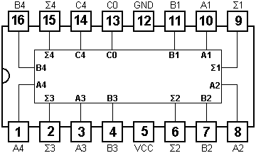

Set: C4 = COUT, C0 =0

***Strobe = Low***

**MUX Connection:**

**Make 4:2 Mux to 2:1 Mux in the following way**

Short Selector A and B

Selector Data Input (Active) Output (1Y) Output (2Y)

00 1C0, 2C0 1C0 2C0

11 1C3, 2C3 1C3 2C3

Give Inputs:

A2

B2

First IC Connection: A = B= S1 (Selector)

1C0 → A1

A

**1Y**

2C3

2C0

1C3→ B1

**MUX-1**

2C0→ A2

1C0

**2Y**

1C3

2C3→ B2

B

**S1**

A1

B1

Second IC Connection: C = D = S2 (Selector)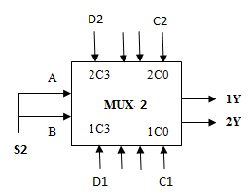

1C0 → C1

1C3→ D1

2C0→ C2

2C3→ D2

|  |  |  |  |  |  |
| --- | --- | --- | --- | --- | --- |
| Selector: S1  (First MUX) | OUTPUT of MUX-1 | | Selector: S2  (Second MUX) | OUTPUT of MUX-2  **1Y 2Y** | |
| **1Y** | **2Y** |
| 0 | A1 | A2 | 0 | C1 | C2 |
| 0 | A1 | A2 | 1 | D1 | D2 |
| 1 | B1 | B2 | 0 | C1 | C2 |
| 1 | B1 | B2 | 1 | D1 | D2 |